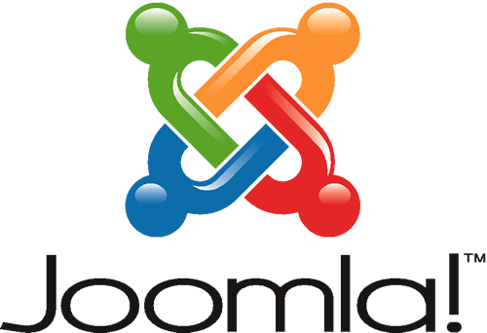

10 advantages of using joomla ?

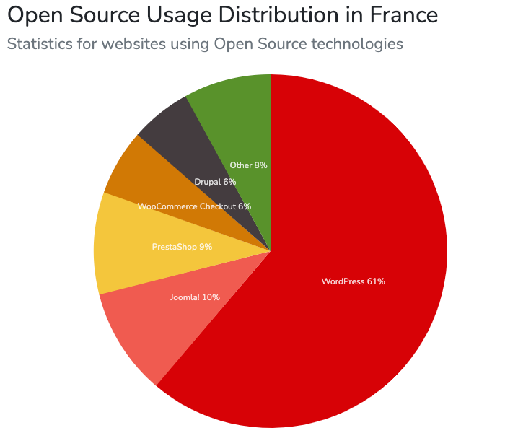
-Joomla is developed in open source so that everyone can download it for free. It uses PHP as the primary language and supports MySQL alongside. PHP and MySQL in Joomla make it possible for many volunteers to continue their contributions in optimizing the code and creating new extensions.

- It costs money to hire people to configure it. However, if you download Joomla now, you can instantly have a website and easily configure it all at free cost.

-Joomla is well suited for setting up an online store. Joomla has number of shopping cart extensions which lets you create e-commerce website easily and smoothly . Shopping carts need to be secure and need to avoid the spams.

-On the login form, you can add CAPTCHA and secure your store from spammers. Here is the official documentation to add ReCAPTCHA on your Joomla website.

-The backup extension allows you to backup your e-commerce store. There are many free and pro eCommerce Joomla templates with appealing designs that can be easily customized. It has everything you need to keep your website steady, including tracking your website analytics, social marketing, affiliate marketing, and SEO optimization.

-Joomla offers a straightforward menu creation tool that benefits people without any experience. The tool allows you to create a hierarchical menu that points to different locations. You can choose the style of the menu based on any of the templates you have installed.

-Joomla offers multilingual support, enabling you to build the leading site in English and create the same website in other languages . There are a few extensions that can work with the older versions of Joomla to support multiple languages. Supporting multiple languages on your website is essential if you have many visitors from foreign countries. It will make it easier for them to understand your website when you provide a version that is translated into their native language.

-Joomla supports PHP, so you don't have to write lengthy code when you want to add features to your website. It is easier to make an edit to the code when you want some changes to the features. Because of PHP, you can connect to the database more efficiently. PHP has a memory of its own, which reduces the server load and increases the processing speed. You will be able to integrate web applications that require PHP in your Joomla site.

